Wearable Health Monitoring System Project

We live in the wearable technology era. Electronics have now evolved to wearable tech for ease of use and advancements. Monitoring a patients health status requires constantly measuring his/her pulse rates. So here we propose a battery powered wearable health monitoring system that constantly monitors patient heart pulses and displays it to user through a wearable band. The system makes use of heart rate sensor to read user pulses and then display it on a display. Also it transmits these values over to the users android phone through Bluetooth module for storing data on the phone. Our system uses an Atmega microcontroller based circuit with sensor and Bluetooth circuitry that is powered by a 9V battery to achieve this task. This system will help many in keeping track of their health and staying fit by tracking their health stats on a phone.

Block Diagram:

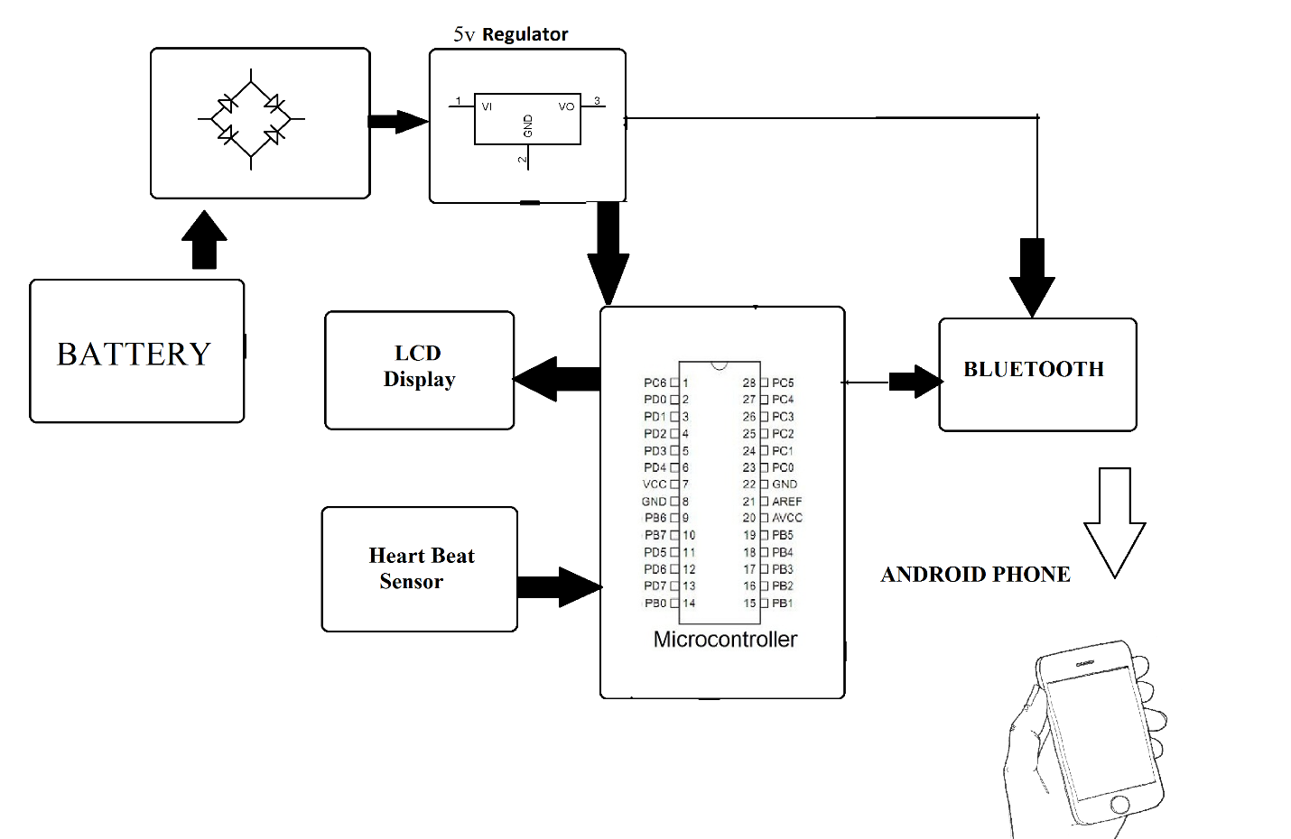
Hardware Specifications

- ATmega328P AVR MC

- Bluetooth Module –
- Heartbeat Sensor

- 9V Battery

- LCD’s –
- Crystal Oscillator –

- Resistors –

- Capacitors –
- Transistors –

- Cables & Connectors

- Diodes –
- PCB – Buy PCB & Breadboards Online

- LED’s – Buy LED Online

- Transformer/Adapter – Buy Transformers & Adapters Online
- Push Button – Buy Buttons & Switches Online

Software Specifications

- Arduino ide
- MC Programming Language: C

